
LESSON NOTE | DETAILED EXPLANATORY NOTES
NEUROSCIENCE & AI
CEREBRAL CORTEX — INTELLECTUAL FUNCTIONS, LEARNING & MEMORY

GRADE 12 - BIOLOGY
■ ■ ■

The Thinking Brain
The cerebral cortex is the thin, folded outer layer of the cerebrum - the large, wrinkled part of the brain. Although only a few millimetres thick, it contains billions of neurons and is the seat of our highest abilities: thinking, reasoning, language, learning and memory. Different areas of the cortex specialise in different jobs, yet they work together to produce the rich mental life we call intelligence.
This lesson looks at how the cortex is organised into lobes, the intellectual functions it carries out, and how the brain learns and stores memories by changing the connections between neurons. It builds on the general design of the nervous system and the senses.
Why This Matters
- The cortex is the centre of thought, language and reasoning.
- Learning and memory are how we gain and keep knowledge and skills.
- Understanding these functions helps explain education and brain disorders.
- Brain plasticity shows why practice improves skills.
Cerebral Cortex, Intellectual Functions, Learning & Memory
Key Learning Outcomes
By the end of this lesson, students should be able to:
- Name the four lobes of the cerebral cortex and their functions.
- Describe the intellectual functions of the cortex.
- Distinguish sensory, short-term and long-term memory.
- Explain how learning changes the connections between neurons (plasticity).
- Relate these ideas to education, skills and brain health.
The Lobes of the Cerebral Cortex
The cortex is divided into four lobes, each specialising in particular tasks. The frontal lobe handles thinking, planning, decision-making, personality, speech and voluntary movement. The parietal lobe processes touch and awareness of the body and space. The temporal lobe deals with hearing, language and is important for memory. The occipital lobe at the back processes vision. Beneath the cerebrum, the cerebellum coordinates balance and movement, and the brain stem controls basic life functions like breathing and heartbeat.
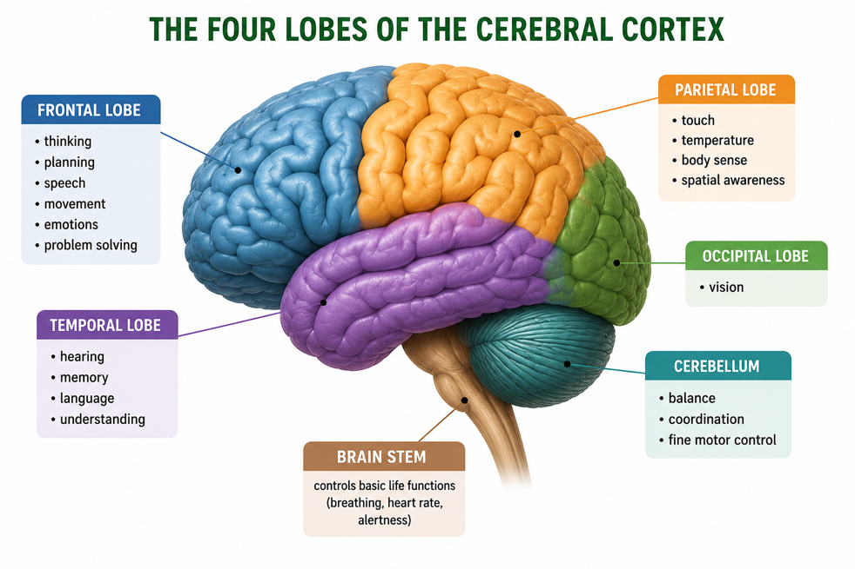
Figure 1: The four lobes of the cerebral cortex, with the cerebellum and brain stem below.
Terminologies and Concepts
Useful terms for this topic:
- Cerebral cortex: the folded outer layer of the cerebrum where higher functions occur.
- Lobe: a region of the cortex specialising in certain tasks.
- Intellectual functions: thinking, reasoning, language, problem-solving.
- Learning: gaining new knowledge or skills through experience.
- Memory: storing and recalling information.
- Plasticity: the brain's ability to change its connections with use.
- Synapse: the junction between neurons that strengthens with learning.
Intellectual Functions of the Cortex
The cortex gives humans their remarkable intellectual abilities. These include reasoning and problem-solving, language (both understanding and producing speech and writing), imagination and planning, decision-making and judgement, and self-awareness. No single spot does all of this; instead, networks of neurons across several lobes work together. For example, having a conversation uses the temporal lobe to understand words, the frontal lobe to form a reply and speak, and memory to recall what was said - all in a fraction of a second.
Memory - Sensory, Short-Term and Long-Term
Memory is usually described as having three stages. Sensory memory holds an impression from the senses for a split second. If we pay attention, information passes into short-term (working) memory, which holds a few items for seconds - enough to, say, remember a phone number long enough to dial it. With rehearsal (repetition and meaning), information can move into long-term memory, where it may be stored for days, years, or a lifetime. Without attention and rehearsal, information is quickly forgotten.
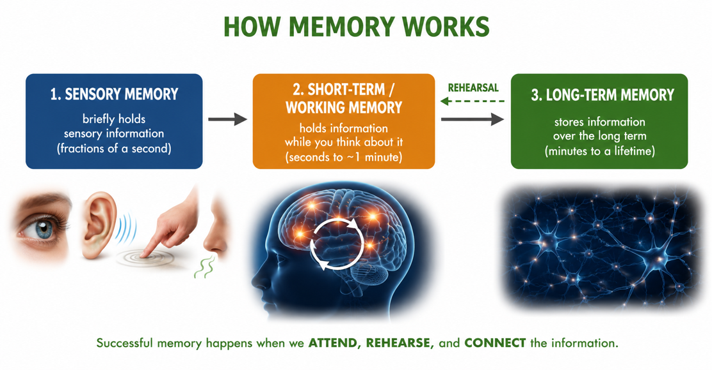
Figure 2: The three stages of memory - sensory, short-term/working, and long-term, linked by attention and rehearsal.
Learning - How the Brain Changes
Learning works by changing the connections between neurons. Each time a pathway of neurons is used, the synapses between them become stronger and faster - a property called plasticity. Connections that are used often are strengthened, while those rarely used fade. This is why repeated practice makes a skill easier and more automatic, whether it is reading, doing mathematics, or playing a sport. In effect, learning rewires the brain a little each time, and memory is stored in these strengthened networks of connections.
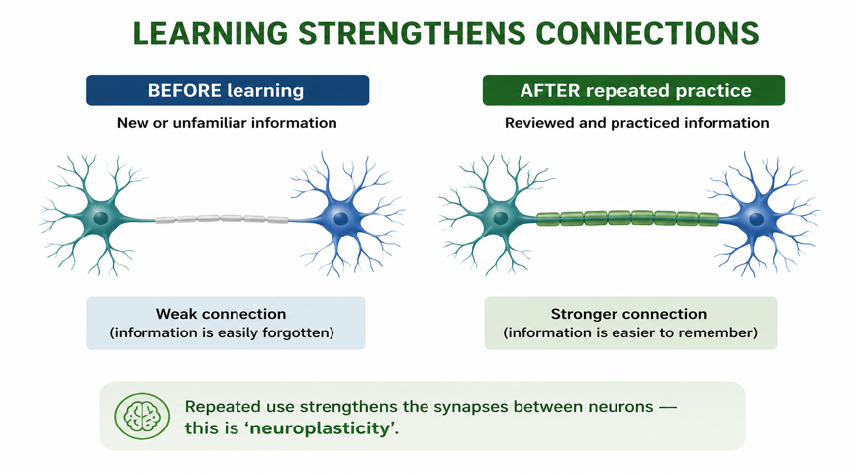
Figure 3: Learning strengthens the synapses between neurons - the basis of brain plasticity.
Why This Matters
- Education - knowing how memory and learning work helps students study effectively.
- Skills - plasticity explains why practice and repetition build ability.
- Health - it helps explain memory loss, dementia and brain injury.
- Recovery - plasticity lets the brain relearn after damage such as stroke.
PNG Context Example
These ideas are directly useful for learning in Papua New Guinea. Understanding that rehearsal and active practice move information into long-term memory encourages effective study habits - spacing revision, testing oneself, and linking new ideas to what is already known. It also highlights the importance of health and nutrition for the brain: conditions such as cerebral malaria, malnutrition in early childhood, and head injuries can affect memory and learning. Appreciating plasticity is encouraging, too - it shows that ability grows with effort and practice, not fixed talent alone.
References & Related Documents
Source Documents
- STEM Biology Syllabus - Grade 12. Thema: Neurophysiology; Module: Cerebral Cortex, Intellectual Functions, Learning and Memory. Department of Education, PNG.
- Biology Standards-Based Syllabus, Grades 11 & 12 (PNG SBC 2020) - Strand 2: Life; investigate the structure and function of the brain, including learning and memory.
Further Reading & References
- OpenStax Biology - The Brain; The Cerebral Cortex; Learning and Memory. https://openstax.org/books/biology
- Khan Academy - The brain, learning, and memory. https://www.khanacademy.org/science/biology/human-biology

